# Experiment 1

**AIM:** WAP introducing Xampp and write steps for its installation.

## XAMPP INTRODUCTION:

XAMPP is an abbreviation where X stands for Cross-Platform, A stands for Apache, M stands for MYSQL, and the Ps stand for PHP and Perl, respectively. It is an open-source package of web solutions that includes Apache distribution for many servers and command-line executables along with modules such as Apache server, MariaDB, PHP, and Perl.

XAMPP helps a local host or server to test its website and clients via computers and laptops before releasing it to the main server. It is a platform that furnishes a suitable environment to test and verify the working of projects based on Apache, Perl, MySQL database, and PHP through the system of the host itself. Among these technologies, Perl is a programming language used for web development, PHP is a backend scripting language, and MariaDB is the most vividly used database developed by MySQL.

## STEPS FOR XAMPP INSTALLATION:

Step 1: Download

XAMPP is a release made available by the non-profit project Apache Friends.

Step 2: Run .exe file

Once the software bundle has been downloaded, you can start the installation by double-clicking on the file with the ending .exe.

Step 3: Deactivate any antivirus software

Since an active antivirus program can negatively affect the installation process, it’s recommended to temporarily pause any antivirus software until all XAMPP components have successfully been installed.

Step 4: Deactivate UAC

User Account Control (UAC) can interfere with the XAMPP installation because it limits writing access to the C: drive, so we recommend you deactivate this too for the duration of the installation process. To find out how to turn off your UAC, head to the Microsoft Windows support pages.

Step 5: Start the setup wizard

After opening the .exe file (after deactivating your antivirus program(s) and took note of the User Account Control, the start screen of the XAMPP setup wizard should appear automatically. Click on ‘Next’ to configure the installation settings.

Step 6: Choose software components

Under ‘Select Components’, I have the option to exclude individual components of the XAMPP software bundle from the installation. After making the choice, click ‘Next’.

Step 7: Choose the installation directory

In this next step, I have the chance to choose where I'd like the XAMPP software packet to be installed. If you opt for the standard setup, then a folder with the name XAMPP will be created under C:\ . After chosen a location, click ‘Next’.

Step 8: Start the installation process

Once all the aforementioned preferences have been decided, click to start the installation. The setup wizard will unpack and install the selected components and save them to the designated directory.

Step 9: Windows Firewall blocking

The Firewall may interrupt the installation process to block some components of the XAMPP. Use the corresponding check box to enable communication between the Apache server and your private network or work network.

Step 10: Complete installation

Once all the components are unpacked and installed, you can close the setup wizard by clicking on ‘Finish’. Click to tick the corresponding check box and open the XAMPP Control Panel once the installation process is finished.

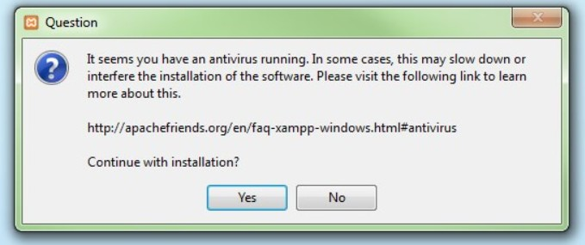

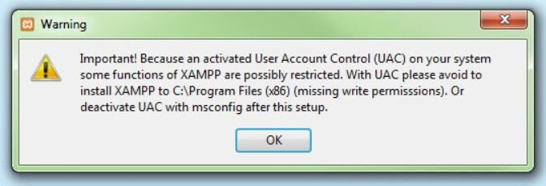

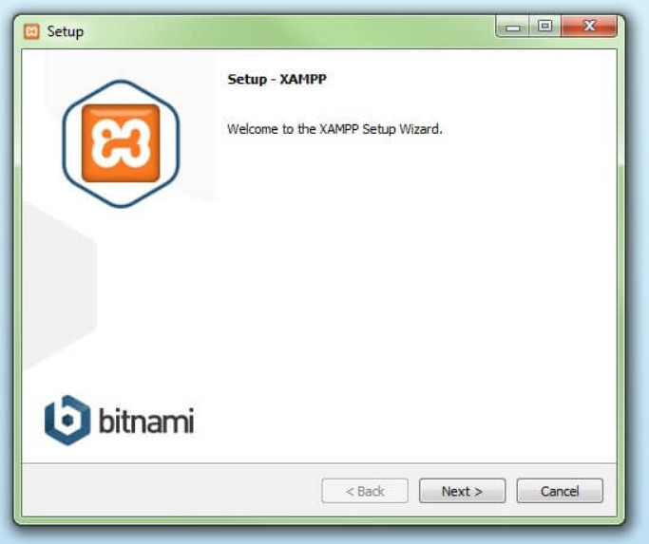

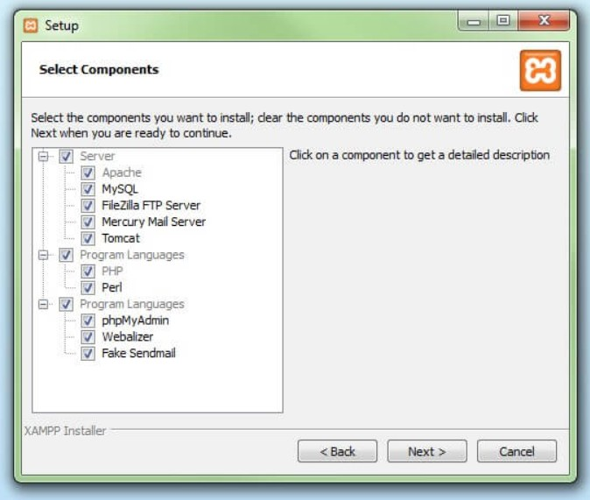

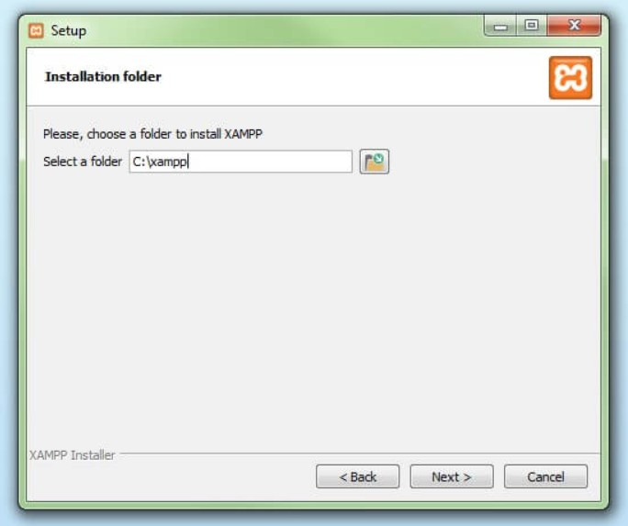

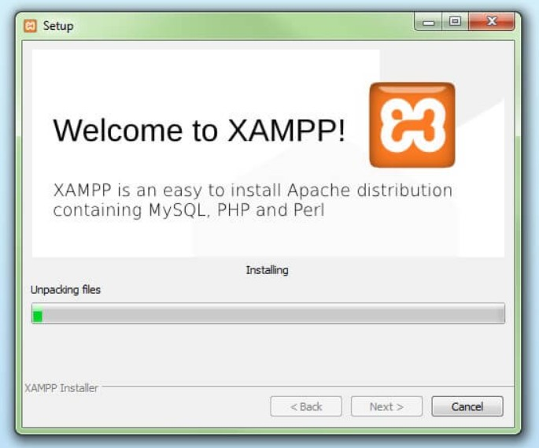

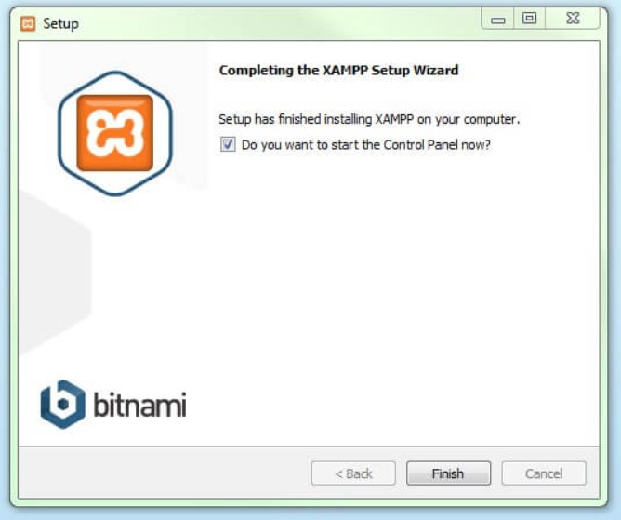

# Experiment 2

**AIM: a)** To write a program of Hello World and deploy it on Xampp.

1. To write a program of printing all six headings and deploy it on Xampp.
2. To write a program printing a paragraph and deploy it on Xampp.

## Source Code:

a)

<HTML>

<HEAD>

<TITLE> AASTHA AGG

</TITLE>

</HEAD>

<BODY>

<H1>HELLO WORLD</H1>

</BODY>

</HTML>

b)

<HTML>

<HEAD>

<TITLE> AASTHA AGG

</TITLE>

</HEAD>

<BODY>

<P>HEADINGS</P>

<H1> This is heading 1. </H1>

<H2> This is heading 2. </H2>

<H3> This is heading 3. </H3>

<H4> This is heading 4. </H4>

<H5> This is heading 5. </H5>

<H6> This is heading 6. </H6>

</BODY>

</HTML>

c)

<HTML>

<HEAD>

<TITLE> AASTHA AGG

</TITLE>

</HEAD>

<BODY>

<H1>PARAGRAPH</H1>

<P>

Paragraph

As an example in student life, everyone wants to do bright results. But lots of hard work is required for that. If someone isn’t ready to working hard, she won’t be able to make a bright result at all.

Some people believe in luck, but luck only favors hard workers. So if you want o keep luck on your side then become one.<BR>

Working hard keeps us focused on our goal. Whatever we are trying to do, we need t keep ourselves focused on that.<BR>

We get motivated when we see a good result because of our work. Everyone should be hardworking and taking that as the biggest aim in life.<BR>

Life could be more beautiful and entertaining when you are an honest and diligent person. These two things can change our life. We will be hardworking and will inspire other people to become so.

</P>

</BODY>

</HTML>

## Output: a)

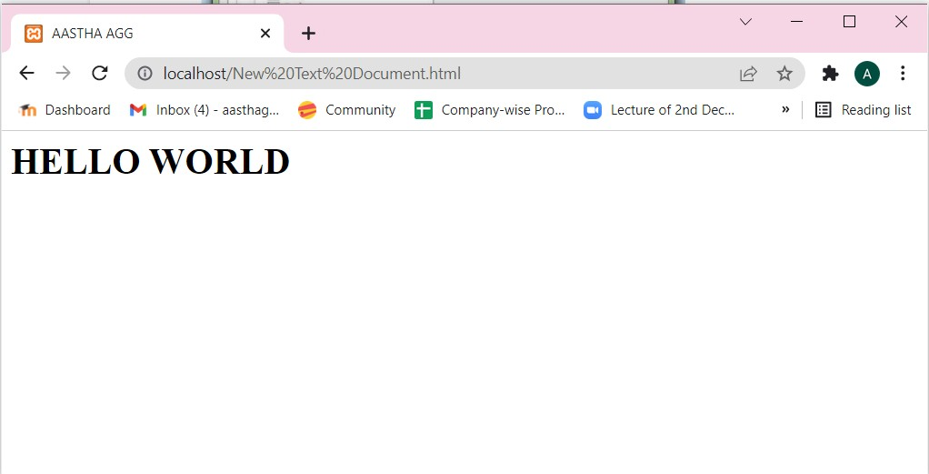

**b)**

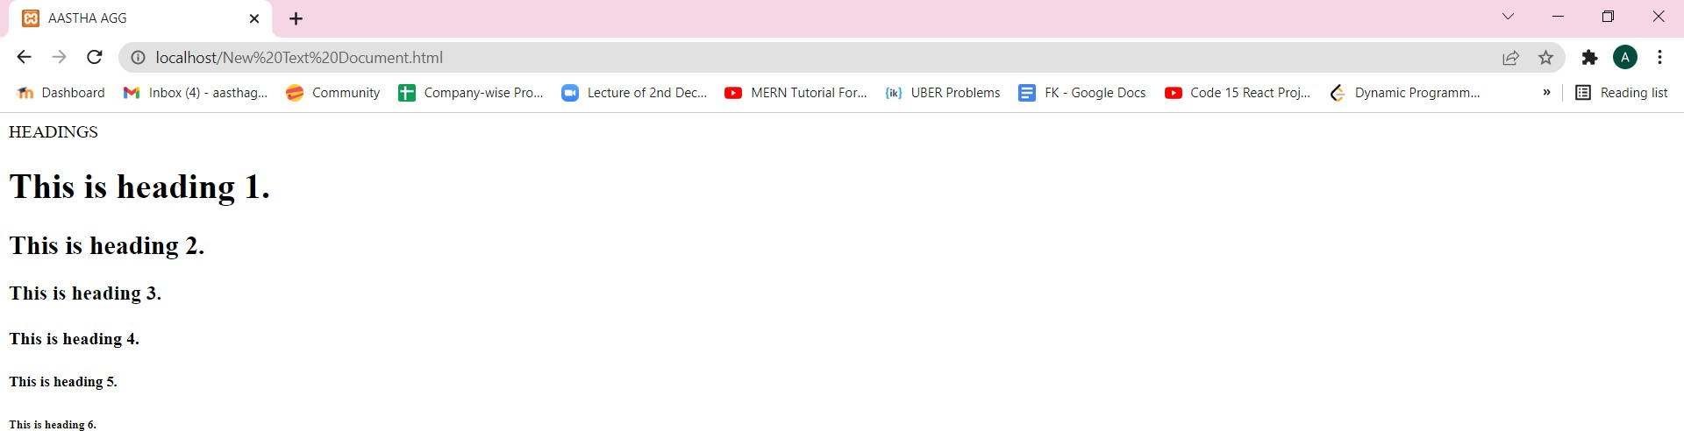

## c)

